**IMAGE RECOGNITION WITH IBM CLOUD VISUAL RECOGNITION**

**INTRODUCTION:**

Image recognition is a cutting-edge technology that has revolutionized various industries, from healthcare and retail to security and entertainment. With the advent of powerful AI and machine learning algorithms, image recognition systems have become increasingly sophisticated, enabling machines to "see" and interpret visual information much like humans do. In this context, IBM Cloud Visual Recognition emerges as a powerful tool that harnesses the capabilities of artificial intelligence to analyze and understand images.

IBM Cloud Visual Recognition is a cloud-based service offered by IBM that leverages deep learning and neural networks to process and classify visual data. This robust platform provides businesses and developers with the tools they need to build and deploy custom image recognition models for a wide range of applications.

**Objectives:**

When implementing image recognition with IBM Cloud Visual Recognition, it's essential to define clear objectives to ensure that the project meets your specific goals and delivers value. Here are some common objectives for using IBM Cloud Visual Recognition:

**Security and Surveillance:** Enhance security by using image recognition to detect and alert on suspicious activities or individuals in real-time surveillance footage Personalized Recommendations: Analyze user-generated images and behaviors to provide personalized product recommendations or content suggestions in areas like fashion, entertainment, or travel.

**Environmental Monitoring:** Use image recognition to monitor and analyze environmental conditions, such as identifying wildlife in conservation efforts or detecting air pollution sources in urban areas.

**Healthcare Diagnostics:** Assist medical professionals by using image recognition for the early detection of diseases in medical images, such as X-rays, MRIs, or CT scans.

**Custom Model Development:** Train custom image recognition models specific to your unique requirements and datasets, allowing you to address highly specialized use cases that off-the-shelf models may not cover.

**Project Statement:**

1) Develop an image recognition into system using IBM cloud visual recognition.

2) Share your passion for photography by uploading images and watch as the systems accurately classifies and describes content.

3) Craft engaging visual stories with the help of AI- generated captions.

4) Connect with your audience through captivating visuals and compelling narratives!

**Project Definition:**

1) The project involves creating the image recognition system using IBM cloud visual recognition.

2) The goal is to develop a platform where users can upload images, and the system accurately classifies and describes the image contents.

3) This will enable users to craft engaging visual stories with the help of AI generated captions, enhancing their connections with the audience through captivating visuals and compelling narratives.

**INNOVATIVES**

**ENHANCING IMAGE RECOGNITION WITH SENTIMENT ANALYSIS:**

**INTRODUCTION:**

1) The image recognition project is dedicated to improving the system's ability through innovation.

2) We plan to incorporate sentiment analysis to generate captions that not only depict image contents but also convey the mood and emotions captured by the images.

3) This innovative feature will allow users to create more engaging visual narratives and connect with their audience on a more profound level.

**INNOVATIVE COMPONENTS**

IBM Cloud Visual Recognition offers a range of innovative components and features that set it apart in the field of image recognition. These components leverage advanced AI and machine learning technologies to enhance the accuracy, versatility, and usability of the platform. Here are some of the innovative components of IBM Cloud Visual Recognition:

**Custom Model Builder:**

IBM Cloud Visual Recognition allows users to create custom image recognition models tailored to their specific needs. This is a highly innovative feature because it enables organizations to address unique use cases and datasets that off-the-shelf models may not cover.

**Transfer Learning:**

The platform leverages transfer learning, where pretrained models can be fine-tuned with your own data. This significantly reduces the amount of labeled data required to train effective custom models, making it accessible and efficient for a wide range of applications.

**Automated Data Labeling:**

IBM Cloud Visual Recognition includes automated data labeling tools that can help streamline the process of preparing data for training. This innovative feature saves time and effort by reducing the manual labeling workload.

**Visual Search and Similarity Search:**

The platform supports visual search, allowing users to find products or content based on images. This feature is valuable in e-commerce, content management, and other applications where visual similarity is crucial.

**Visual Data Insights:**

IBM Cloud Visual Recognition provides insights and analytics on image data, including data distribution, model performance, and confidence scores. These insights help users understand and improve their image recognition models.

**Content Moderation:**

The platform offers content moderation capabilities, which is crucial for online communities and platforms to automatically filter and flag inappropriate or offensive content in user-generated images and videos.

**Real-Time Processing:**

IBM Cloud Visual Recognition can process images in real-time, making it suitable for applications that require immediate analysis and response, such as security and surveillance systems.

**Visual Recognition in Video:**

In addition to static images, the platform supports video analysis, enabling organizations to detect objects, activities, or anomalies in video streams for applications like security, retail analytics, and more.

**Integration with IBM Cloud Services:**

IBM Cloud Visual Recognition seamlessly integrates with other IBM Cloud services and tools, such as Watson Studio and Watson Knowledge Studio, facilitating end-to-end AI model development and deployment.

**Hybrid and On-Premises Deployment:**

IBM Cloud Visual Recognition can be deployed in a hybrid or on-premises environment, giving organizations flexibility in where and how they use the service, including scenarios with data privacy or regulatory considerations.

**Custom Post-Processing:**

Users can define custom post-processing logic to fine-tune the output of their image recognition models, allowing for more specific and accurate results.

**Edge Computing Support:**

IBM Cloud Visual Recognition can be deployed at the edge, enabling real-time image recognition on devices with limited connectivity to the cloud. This is valuable for applications like autonomous vehicles and IOT devices.

These innovative components make IBM Cloud Visual Recognition a versatile and powerful tool for a wide range of industries and applications, from enhancing customer experiences to improving operational efficiency and security. Organizations can leverage these features to develop cutting-edge solutions that leverage the capabilities of AI-powered image recognition.

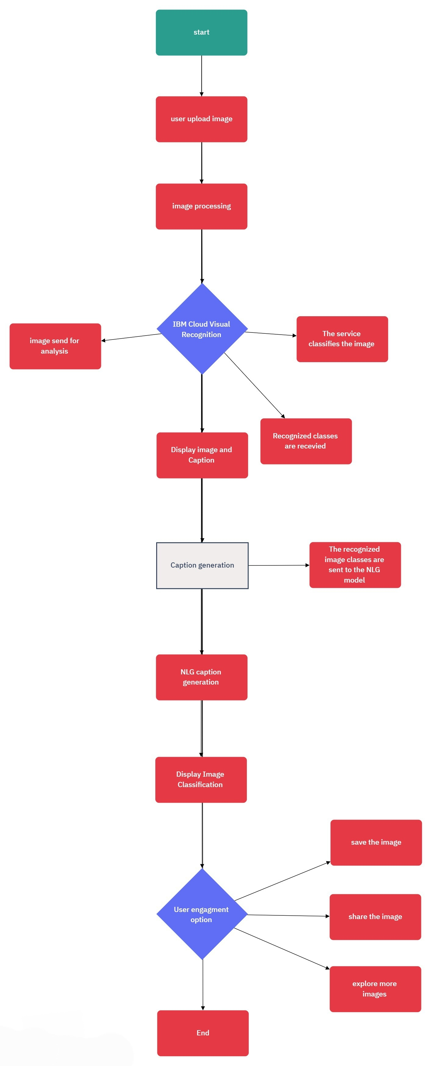**IMPLEMENTATION FLOW CHART**

**WORK FLOW DIAGRAM**

­­­

­­­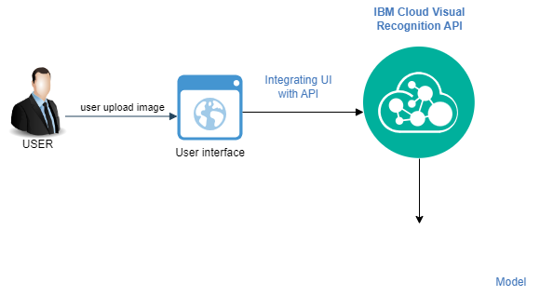

Image classification



Caption generation

**CONCLUSION:**

* Captivate makes storytelling with images easy. It recognizes your photos and adds captivating captions, helping you connect with your audience effortlessly.
* It can effectively transform the design of incorporating sentiment analysis into a fully functional and innovative image recognition system that enhances user’s storytelling abilities and engages their audience on a deeper emotional level.